Inside the container seeing files
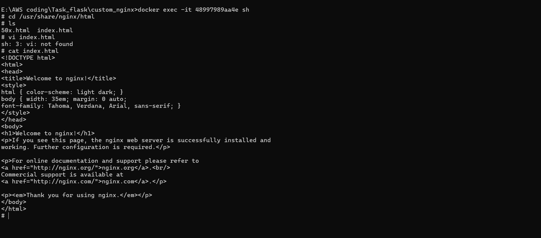
Terminal Execution
I belive you are asking for the terminal or CMD execution . we use docker build to execute the dockerfile and docker compose up for docker-compose.yaml execution which I already given in Git termainal execution . For making sure the files are in same directory I have given the lsiting also below . Execution file structure is already in the git this is just the output . only the demo(jwalapj/custom-nginxdemo:v1) addition of docker-compose file wont be there in git.

Since the image is already present removing and redoing the steps again adinng an demo in the name

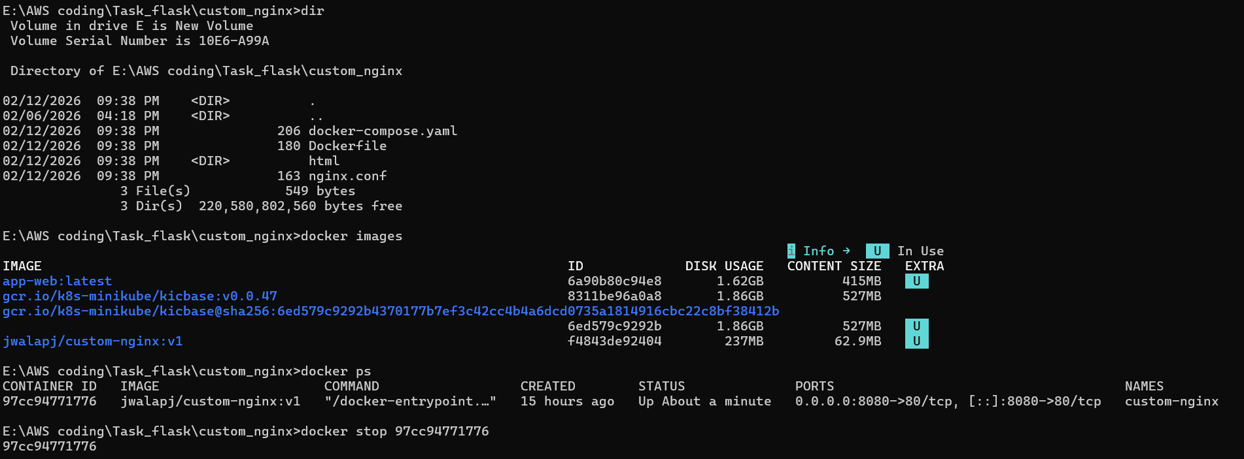

Creating a new image adding demo in the name
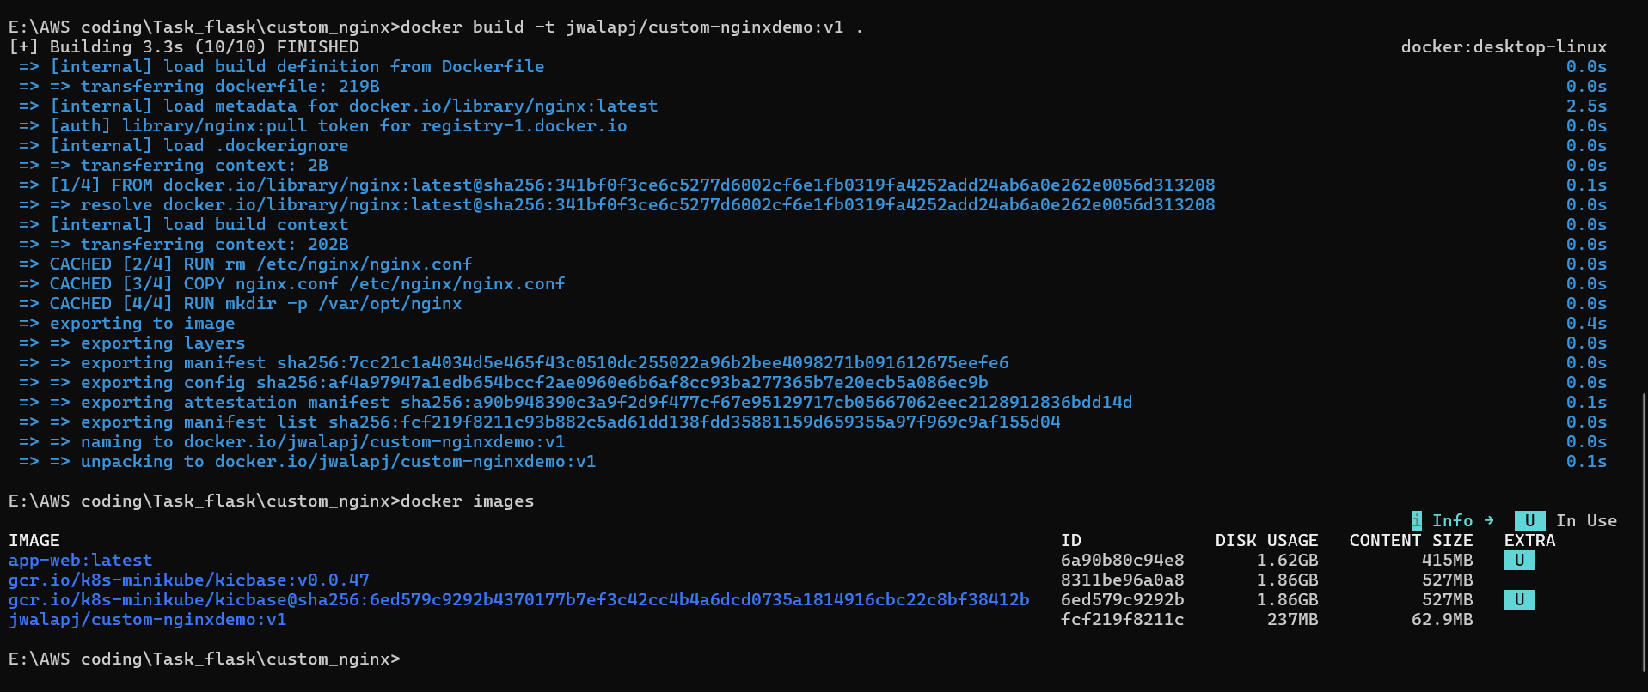

Running the container
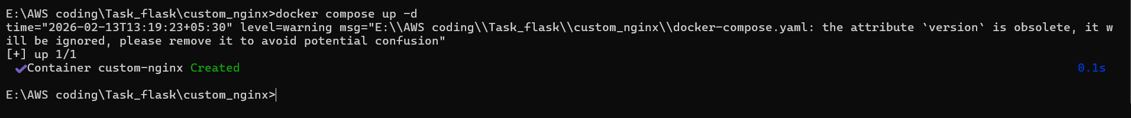

Pushed the new image to the Hub
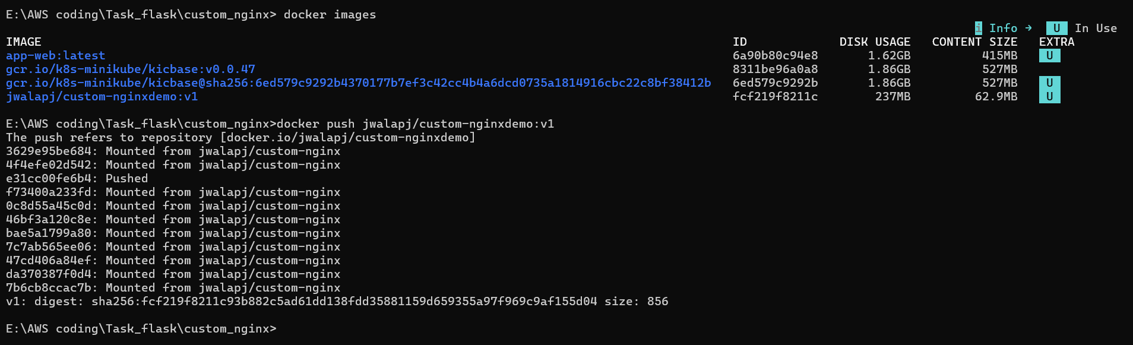
Output of the change in Nginx
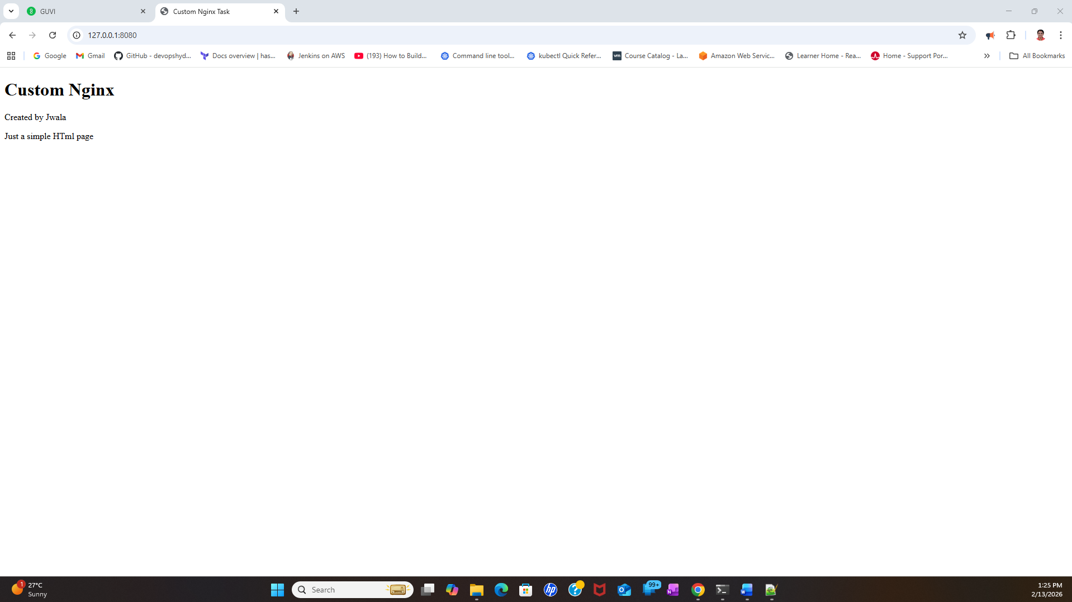

Viewing docker imgae in docker Hub
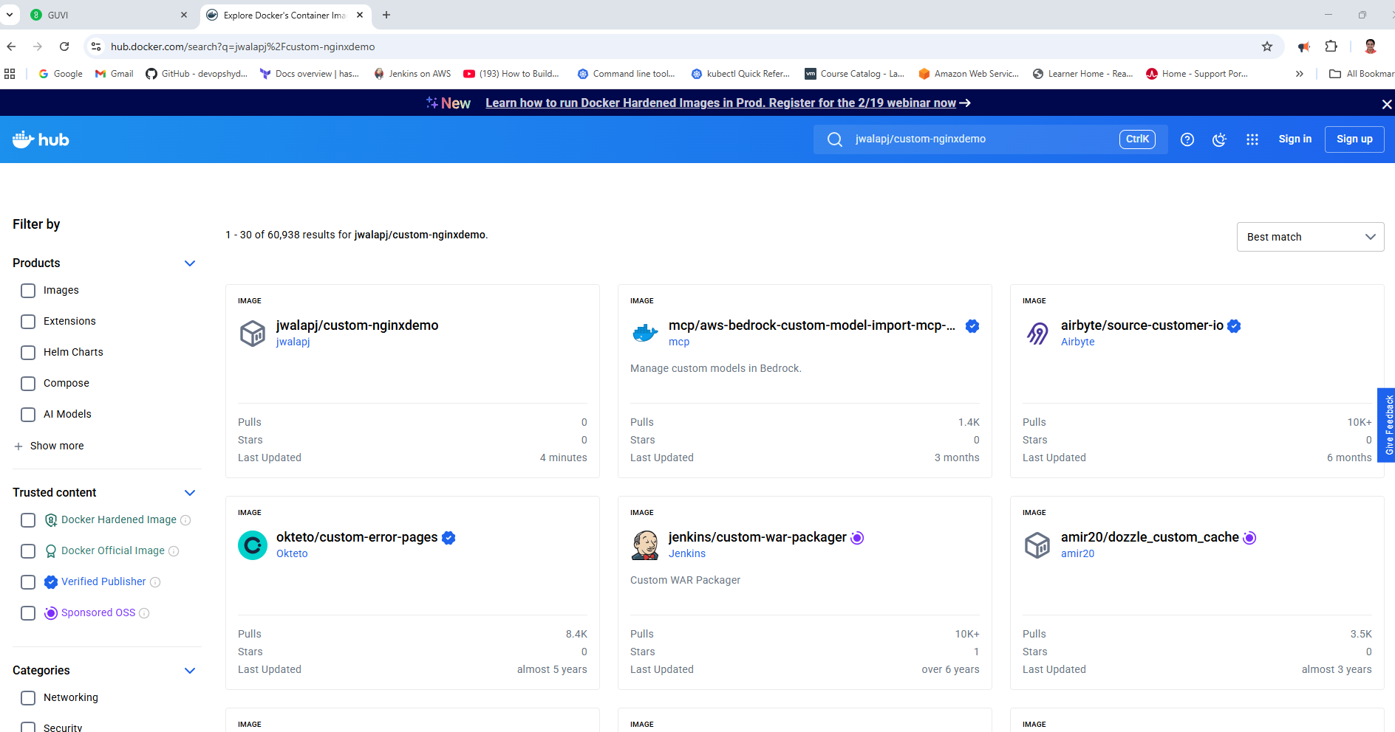

GIT terminal execution

